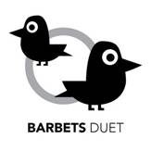 | BARBETS DUET  Update & Progress Report  July 2012

Based on  Site visits  & email updates  August 2010 – July 2012  Compiled by  Barbara Heinzen  New Baltimore, New York  July 2012  Using reports from:  Mwajuma Masaiganah,Tanzania  James Magode Ikuya, Uganda  Rose Lyimo, Tanzania  Oby Obyerodhyambo, Kenya  Sammy Muvelah, Kenya  Chris Jones, UK  Barbara Heinzen, USA  Debrief of  Thomas Dauncey, UK intern, 2011 | 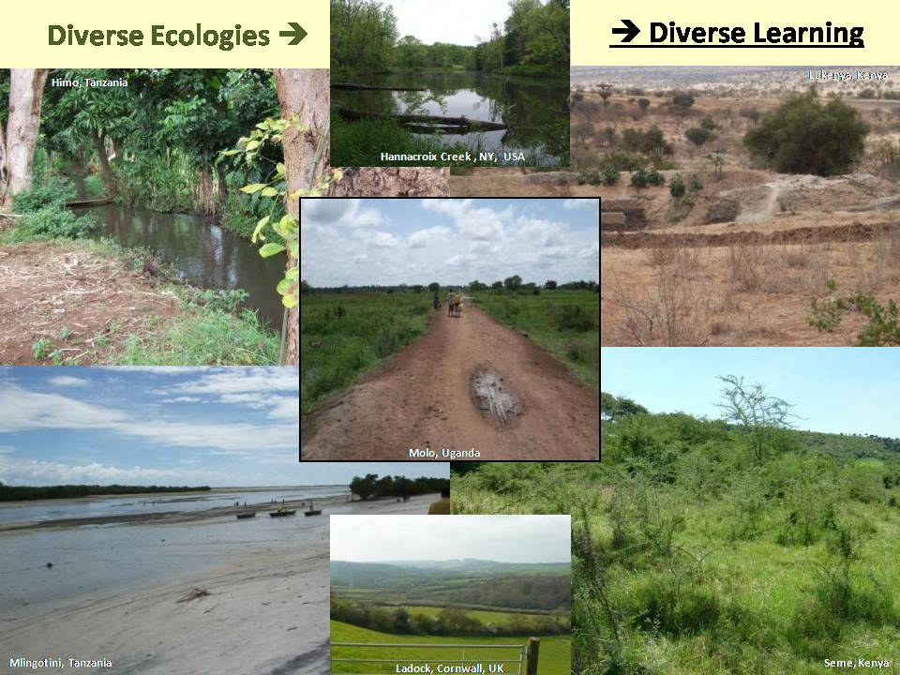
A mature oak tree can support 284 species of insect, provide food and nests for birds, acorns for mice and squirrels, and habitat for fungi. Its ‘life’ value is very high; its economic value is only realised once it is dead. Today’s environmental crisis is the consequence of this paradox.

The Barbets Duet will create new economic systems that reward the abundance of life.

A Short History & a Long Future

Barbets Duet from 2006-2010

The founding partners of the Barbets Duet describe it as a business idea, not a charity. It is explicitly designed to experiment with the rules and structures that can underpin a human-ecological system that supports all forms of life, including mankind, for a very long time.

The first Concept Note was written by Barbara Heinzen and Oby Obyerodhyambo in 2006. Two core principles were especially important: 1) learning from both African and Western knowledge on equal terms, and 2) demonstrating what is possible on learning sites open to anyone. In 2007, the Barbets Duet Concept was tested in East Africa, India and Europe. The concept was largely endorsed, especially in East Africa and India where local knowledge is often ignored, but how does a concept begin to move off the page?

In 2008, during the worst of the Kenyan post-election violence, five people in East Africa agreed to create the first Barbet Learning Sites. As Oby Obyerodhyambo said at the time, ‘You can see we need this now more than ever.” One year later, in 2009, the first UK learning site, Woodland Valley Farm in Cornwall, joined the group. In 2010, the first US learning site was bought, providing land on the Hudson River in upstate New York. In 2011, a second learning site was added in Bagamoyo, Tanzania. By setting up sites in the United Kingdom, United States and East Africa, the principle of cultural equity is firmly established, as well as increasing the diversity of learning that is possible. At each site, the partners are using their own land and communities to experiment with ways to restore and maintain environmental goods while also supporting themselves and inspiring people around them.

People from the participating sites try to meet at least once every calendar year. The first meeting, known as the Invention Convention, took place in 2009 on the coast of Tanzania, hosted by the Msi Choke Seaweed Growers Cooperative of Mlingotini. As the first occasion when everyone met, this is the formal date for the founding of the Barbets Duet. During the day, everyone at Mlingotini presented a learning site with its activities and goals. The group also had a tour of Msi Choke’s seaweed farms and, in the evening, the Founding Partners discussed basic principles of governance.

Ten months later, in August 2010, six of the founding partners met outside Nairobi at the home of Oby and Hilda Obyerodhyambo, in Nkoroi, Kenya. Known as the Nkoroi Partners Meeting, this discussion used progress reports from each site to discover useful principles that are important in establishing a learning site. The long day also included a tour of the Nkoroi compound where many new practices are being tested on a small scale.

Major events 2011-2012

The partners agreed to hold their 2011 Convention in Molo, Uganda. However, scheduling conflicts meant that instead of everyone gathering at the same time in one place, a small group from Mlingotini, Tanzania, along with Barbara Heinzen from the UK, travelled to each site. This journey in April 2011, is now known as the Safari Convention. It was just as productive as the other meetings, as can be seen from a short report found on the Barbets page at www.barbaraheinzen.com . Once again, people walked around each site while comparing lessons learned in formal and informal settings. During the meeting in Molo, the group had the first report on using a biodiversity index at Seme, Kenya, delivered by Thomas Dauncey, a gap year English student who worked at the Seme Learning Site with two young Kenyans, Robert Ouko Osewe and Silas Otuoma Awiti, now at Nairobi University. The previous year, Seme had hosted three new graduates from Emory University in the USA, the first Barbet interns to work in East Africa.

In addition to the initiatives at each site, there have been continued efforts to publicise the Barbets Duet as a whole and make our thinking better known. In June 2011, the Partners submitted their first application for financial support. This application is competing with many others and may not succeed. However, it helped to refine the Partners’ collective goals and it also introduced Barbet principles and thinking to a new audience. That same month, Barbara Heinzen introduced the Barbets Duet to a conference in Finland on Trends and Future of Sustainable Development. A separate paper, “Just Begin”, based on her presentation was included in the Conference papers (see page 96; address: http://ffrc.utu.fi/julkaisut/e-julkaisuja/eBook_2011-15.pdf ). It is also available on the Barbets page. In June 2012, Barbara Heinzen was asked to give a talk on the Barbets Duet in Belgium. Earlier, Julie Allan asked for an article to include in the Summer 2012 edition of the journal for the Association for Management Education and Development (AMED) on wisdom in organizations, (http://www.amed.org.uk/page/welcome-to-e-o-p-summer-2012). Julie wanted a description of the Barbets Duet as a new type of management during a time of systemic change. ( http://www.barbaraheinzen.com/UserFiles/File/Wisdom%20&%20systemic%20change%20E-O&P%20journal%20summer2012.pdf ).

The influence of the Barbets Duet is moving beyond words as others pick up our ideas. In 2010, the Partners agreed not recruit new partners with new sites until we had a better idea of how to govern the collective. However, Oby Obyerodhyambo recognized that ‘There is a movement which will inevitably happen’ as others imitate and multiply what we are learning. In April 2012, three people in the Yeoville neighbourhood of Johannesburg, South Africa, asked for a Skype meeting so they could learn what was involved in setting up a learning site there. In India, another handful of people are looking for land where they can start their own learning site near Pune in Maharastra state. We are also seeing neighbours around each site take up the successful initiatives of the Barbet Partners. Some of these are described below.

The 2012 Convention of the Barbets Duet will be held in East Africa in November, possibly in Hima, Tanzania. The Partners are hoping that an American filmmaker will be there to put together a short documentary on the work of the Barbets Duet. They are also hoping they will be joined by a Singaporean civil servant currently working at the government staff college. Ideally, he will find useful ideas to take back to Singapore and might even consider sending some people to East Africa to learn from our work.

Since the Safari Convention in April 2011, each learning site has continued to develop according to its own conditions and has begun sharing email progress reports with the other sites. The balance of this report will offer a photo essay of the current sites, based on written site reports and photographs from April 2011 and earlier visits. The report concludes with a discussion of common themes and lessons.

During the Safari Convention visit to Seme, Kenya, it was observed that the 2006 Concept Note had described the Barbets Duet as a 20-year experiment. “It is not twenty years,” said Oby as we walked around Seme. “This is work that needs at least another generation.”
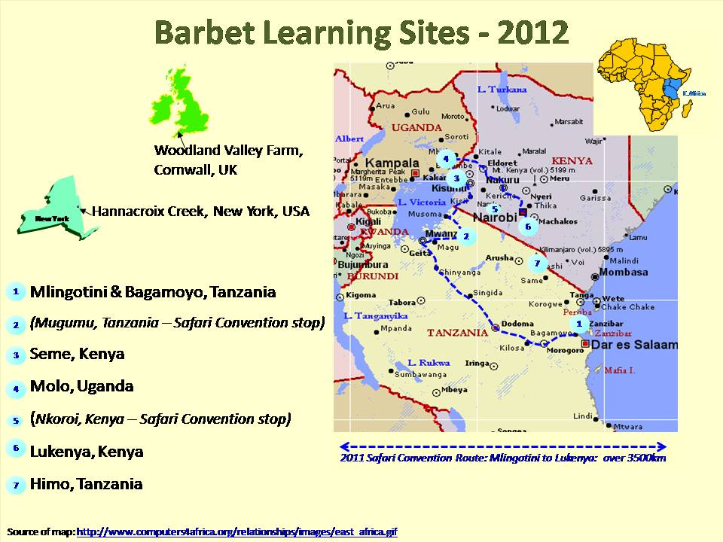

Seme, Kenya

Oby & Hilda Obyerodhyambo

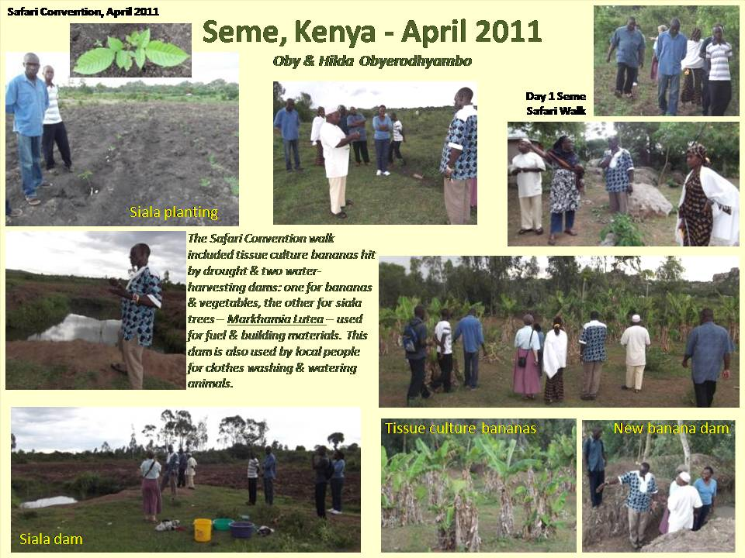  Seme was the first Barbet site visited during the Safari Convention. The travelers arrived in the mid-afternoon and left late the next morning to travel to Molo, Uganda. | Oby and Hilda Obyerodhyambo’s site is in Seme, between Lake Victoria and the Busia/Kisumu Road in Kenya. Although patches of swampy ground indicate a relatively high water table, the area is prone to harsh and unpredictable dry spells. Maize is considered the ‘king’ crop in the area, but has often failed in dry weather.  In response to this geography, two major lines of experimentation have been followed in Seme: 1) diversifying production, including cereals, vegetables, agro-forestry and animals; and 2) digging dams for water harvesting.  Each crop has had its own problems, but overall, the result has been that “Mama and others are seeing that crops other than maize can deliver them from perennial crop failure.”  With this experience behind them, they are now expanding production in several areas, especially irrigated vegetables and trees, planting Siala (Markhamia Lutea) and Moringa, using seedlings from Sammy Muvelah’s site in Lukenya . “My mother recalled how she had used Moringa to feed my late dad who suffered from Diabetes. She did not need much convincing to be part of the planting. … the uses of Moringa are so many.”
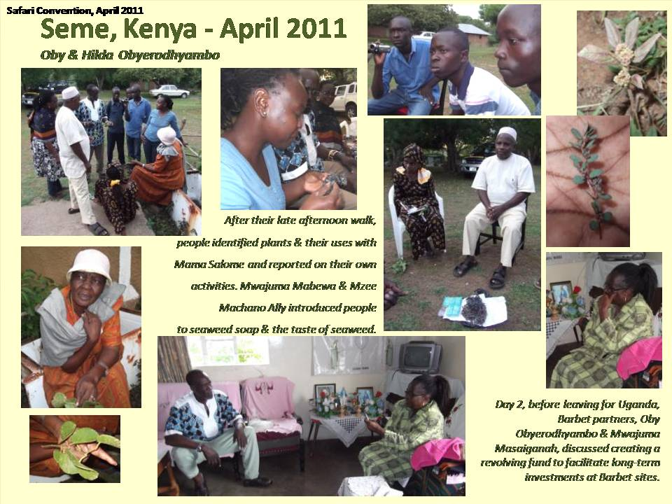  LESSONS LEARNED: “First, ensure that the livelihood is taken care of. The vegetable farm has given my brother motivation and income so that he has managed to grow many fruit and other trees.  “Secondly, a better weather prediction can be really useful. Had we been sure that the rains would be so good this year we would have diverted resources to plant 4,000 trees. [But] we had no assurance of the rain … climate change really hampers planning.” | Neighbours are both benefiting from, and disrupting the Seme experiments, but some have begun to imitate and protect what is being done. One previously ‘nuisance’ neighbor has now planted his own vegetable crops, irrigated from Oby and Hilda’s dam. This man has now become “the leader of the vigilantes protecting this water source,” from misuse by animals who can collapse the walls if they wade in.  In February, 2012, Oby wrote “The entire country is in the clutches of a severe drought currently. … the community are slowly realizing that this dam we built might be the only source of water for their domestic use and watering their cows. Already they are marveling at the lush green leafed spinach, collards, kale, amaranth, pigeon-pea vegetables that we have because of irritation. “ Onions have been an especially successful crop – unpalatable to animals and drought resistant.  The latest experiment in Seme is a new breed of dairy goats which “caused quite a stir. We intend to cross-breed them with local goats to improve stock. This we will do as a community service or maybe for a small fee.”  Future plans include fencing off a small wetlands to become a traditional medicinal trees and herbs arboretum. Fish farming and a mango tree plantation are also on the list.

Molo, Uganda

James Magode Ikuya & MIAFI – Molo Integrated Agric-Farming Initiative

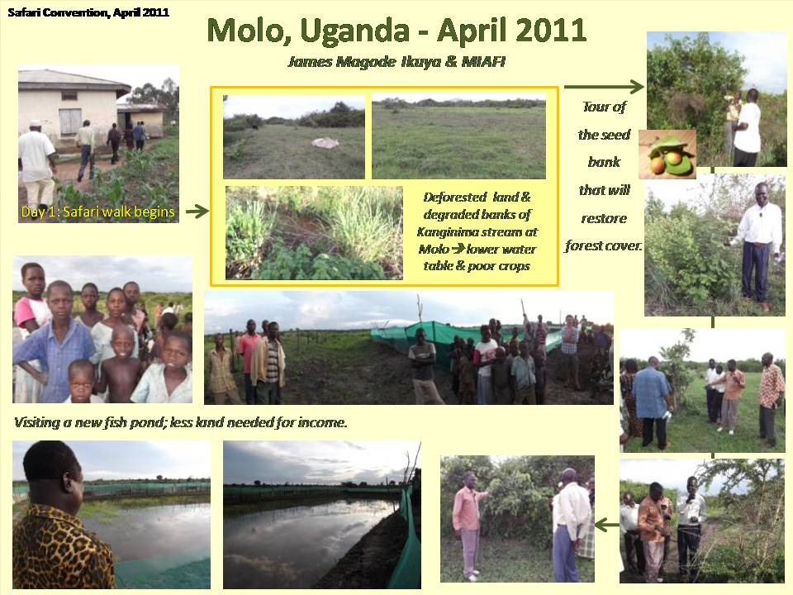  “There is immense market for fish in the country as the available fish from Lake Victoria is mostly exported by the large scale processing investors, leaving mere bones for the local people.” | By the end of 2008, twelve families sharing 21 km of clan land along the Kanginima stream in Molo, Eastern Uganda had agreed to create a Barbet Learning Site. Their reasoning was stark:  “Human settlement used to exist only on the higher grounds. Activities at the stream used to be restricted to wild life and watering of domestic animals enabling flourishing of wild growth. The stream water was clear blue, teeming with fish species and other marine kind.  “With pressure of increased population and the changed activities along the stream bank, the environmental landscape has been drastically debased. … The stream which was once alive with many species of fish and life now only has occasional frogs and famished crabs. It has been denuded of all plant life. Places which were once wetlands are scorched dry.  “… Peasant poverty is characteristically the embedded norm of existence, creating a vicious circle of helplessness, hopelessness, environmental degradation and misery”.  MIAFI was formed to rouse a community effort around environmental regeneration. Fish farming & poultry will provide new incomes, and stream banks are being restored, preventing rain run-off and soil erosion, while encouraging animals and birds to return.

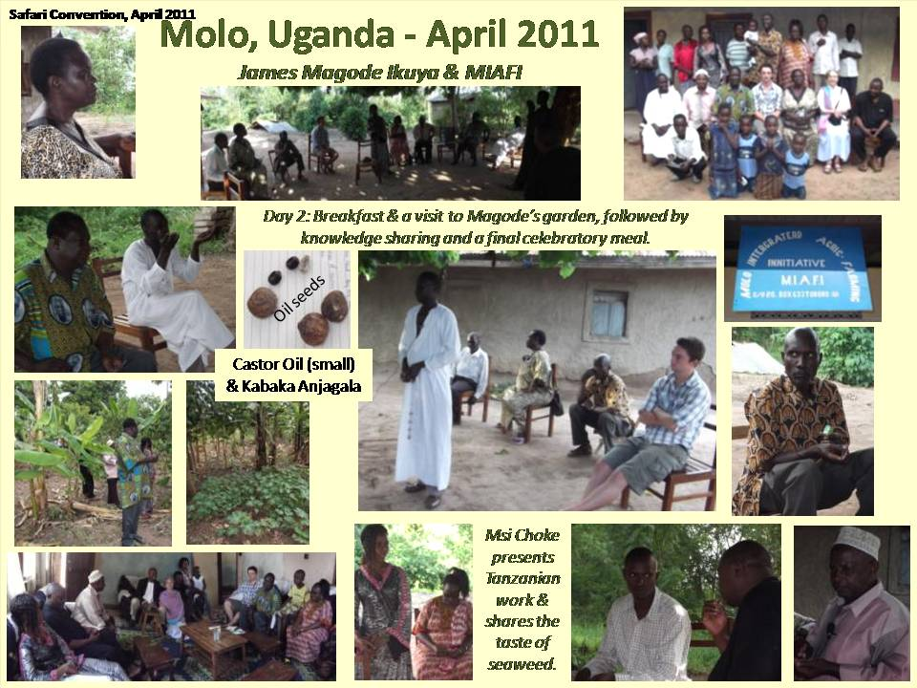  LESSONS LEARNED: “The inescapable imperative is that we must first assure the site of its economic viability …The example and visibility of our site is the basis of its eventual success.”  “We must continue to keep alive the morale and enthusiasm of members … it is futile, at the start, to be very euphoric for easy dividends. …and can lead to fatal demoralization.”  “Everyone recognizes the difficulties of our beginning, but there is no wavering over the legitimacy of the …ideas.” | The first fish harvest took place in February 2012, but fell short of expectations. Greater control and supervision of the site is needed, both to prevent unwarranted intrusions and pilferage and ensure greater care in nurturing the fish. That is turn requires greater investment in infrastructure and the financing to pay for it. This is proving to be difficult.  “There is no existing financing portfolio in the banking sector for the fish-farming or general environmental issues.” There may be funds from the Uganda Development Bank, but little support so far from NEMA, the National Environmental Authority. “Last year’s colossal splurge for the general elections seems to have left the country’s Treasury with ghastly scars.”  There has been some success in growing seeds of the Kabaka Anjagala but others failed ‘due to the vagaries of the weather patterns’ and insufficient supervision. The Kabaka Anjagala can produce 400 kg/year per tree and has multiple uses. Together with castor & jatropha seeds, these can provide new sources of oil and fuel, but progress is still slow.  Stream bank regeneration has also begun: "We are … identifying and specifying the native species that can regenerate our stream bank areas. We have planted some different species of reeds and bamboo shoots for trial.” New species from Lira and Acholi are also being tried.

Lukenya, Kenya

Sammy Muvelah

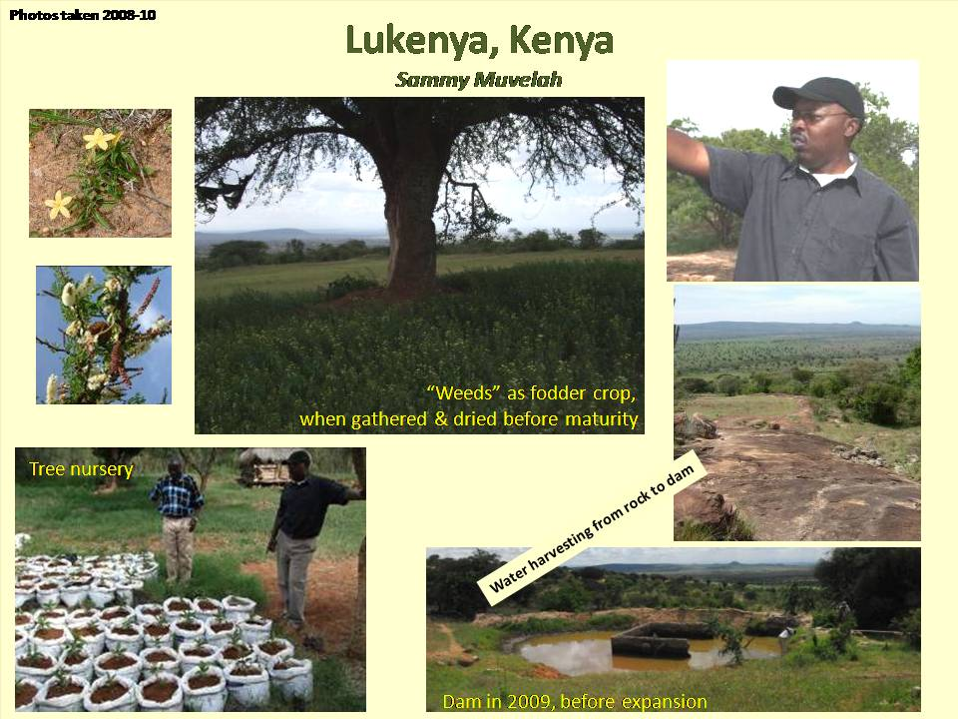 | Sammy Muvelah’s site is on a rocky hillside about 60 km from Nairobi, surrounded by dry plains suitable for game and herding. When group ranches failed, the land was split up and rain-fed agriculture was tried, but often failed.  Believing this hillside had been tree-covered, Sammy began a tree nursery, watered by rain collected off a large rock on the hill. The most successful tree so far has been the Moringa which has multiple uses and is drought-tolerant.  After initial scepticism, his neighbours are following his lead. “Now moringa has become a big thing in my neighbourhood, because last year (2011) they were eating it as a vegetable when things were very bad.”  “The neighbours appreciate the dam more than before, tree planting is picking up, and people are coming to get seedlings. They no longer let their goats wander into my trees because they realise trees are expensive.”  When Sammy first fenced his land, various weedy plants quickly appeared. Recently he learned from his neighbour, Mzee Zao, that some can be good fodder crops. “I found about 5 -6 so-called weeds that are viable as animal feed, but only when they are premature.”
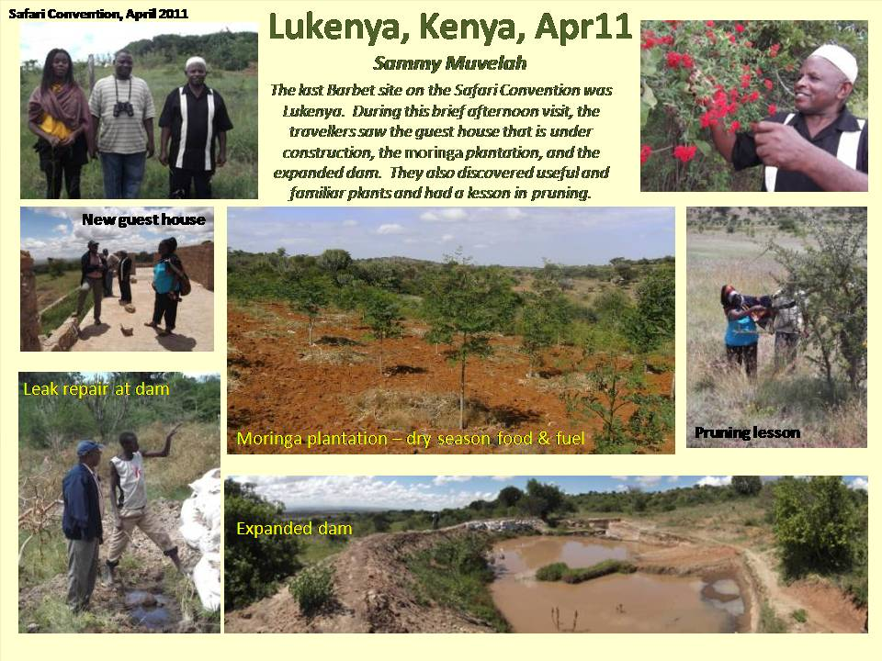  LESSONS LEARNED: “ You have to create an ecosystem around where you are. If people don’t have any economic livelihood, you ... just have environmental problems and a crisis waiting to happen.  “It has worked out. It has been a long struggle, but methods of dealing with the challenges are emerging just from interacting with the people and getting their feedback.” |  | As an experienced businessman, Sammy is constantly looking for viable markets. He is currently thinking about two markets: for moringa tree seedlings and another for dried, crushed fodder for animals. Finding a way to pay a decent wage planting the moringa seedlings, however, has not been easy.  “The confusion is: if I invite someone to do for me moringa in my compound he wants to be paid 20sh for every successful seedling ... which is the minimum price for a seedling at the market. It takes 3 weeks to put down 5000 seedlings in paper bags. ...[yet] I have provided the seeds and the bags and soil and the water. ... He doesn’t realise that it is not economically sensible for me to do that.”  The market in animal feed, based on crushed and dried premature plants, is more promising. In limited quantities, these are excellent feed, and improve animal nutrition. “I have gone to the towns and nearby marketing areas and asked people if they will put my feed out for me. And they say yes. Also people come to my place to buy grass, so I know the market is there. ... “This year, I am definite I can make money.”  Update: 25 July 2012: “After a visit to Lukenya last week, I am happy to report that there is coming a healthy forest of about 1000 moringa trees. The lessons learnt are invaluable.”

Mlingotini, Tanzania

Msi Choke Seaweed Growers Cooperative

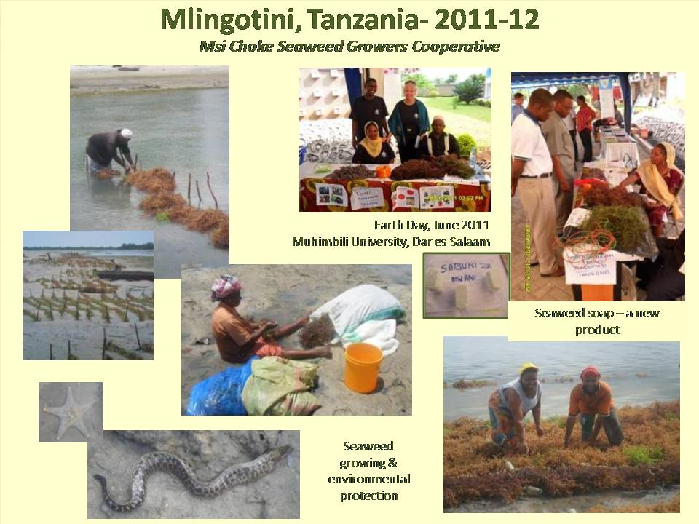 | Mzee Machano Ally and Mwajuma Mabewa represented Msi Choke during the Safari Convention. In an email the month after the tip, Mwajuma Masaiganah wrote, “They have gained a lot out of the trip. And indeed, they are in very high spirits and the whole village is so delighted and are asking a lot about the trip.”  Thanks to Anne Outwater, one of the Barbets Duet advisers in Dar es Salaam, Msi Choke was invited to present their work at 2011 Earth Day in Muhimbili University, offering good publicity for their work which continues at Mlingotini.  One of their biggest challenges is getting a fair price for their seaweed. Every buyer seems to offer the same price, giving them no alternative. Things looked as though they might improve when a Kenyan businessman in Houston tested the possibility of selling their seaweed directly to American buyers. However, just as he was making progress, he was detained by the US immigration authorities and has not yet been released.  In the meantime, Msi Choke are diversifying their products. They now make seaweed soap for sale and are investing in bee-keeping.

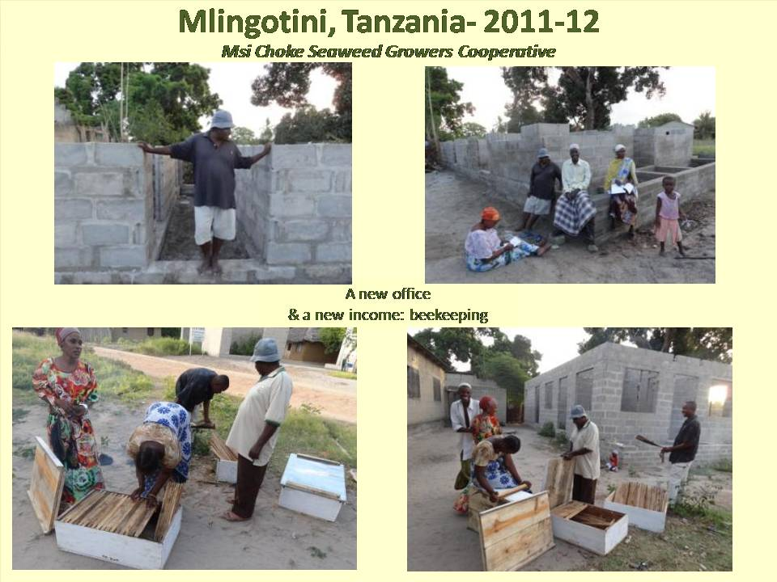  LESSONS LEARNED: To ensure economic viability, diversify production. In addition to selling dried seaweed, Msi Choke are now making seaweed soap and have started bee-keeping. | The major news for Msi Choke in 2012 is that they have saved enough money to build their own office in the village. Now, instead of renting a single room, the new office will have a meeting room, office and waiting room.  In February, their neighbor and Barbet partner, Mwjuma Masaiganah, wrote, “With Msi Choke things are very very fine.”  In May she reported that, “Those people are doing well. The house is up! The roofing is lacking, but otherwise they have done their best, and in a very short time. The construction was well done. And they have gone into bee-keeping. They are doing very good.”

Bagamoyo, Tanzania

Mwajuma Masaiganah & the Mwasama Pre and Primary School

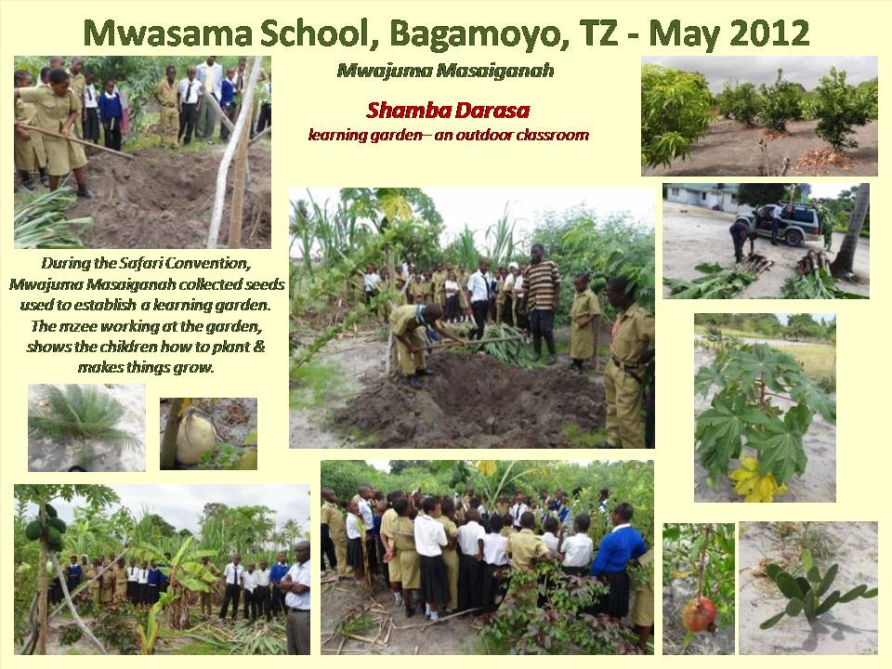  LESSONS LEARNED: One mother said to Mwajuma, “You have really impressed the children.” The Shamba Darasa also demonstrates the value and importance of farming at a time when it is not always respected. | Since the Barbets Duet began in 2008/9, Mwajuma Masaiganah, one of the founding partners, has encouraged the Msi Choke Seaweed Growers Cooperative to be the learning site in her village, Mlingotini. She was too busy with the Mwasama school in Bagamoyo, to create a learning site of her own.  However, during the Safari Convention, Mwajuma decided to start her own learning site at the new Mwasama school compound. Now there is a “Shamba Darasa”, or learning garden, at Mwasama. In February 2012, she wrote:  “For me, actually I started collecting seeds on my way in April [2011] during the Safari Convention and I have planted them. Some have come up, some not. I collected a lot of sugar cane and I have established a teaching farm, the teachers call it “the Shamba Darasa”, a teaching farm or learning garden. They have started using it. We are still working on it. We started in April and we are eating bananas and pawpaws and pineapples and cassava. I planted all sorts of castor seeds from Magode and some are coming up. So I have a lot of plants.”  In May 2012 the garden was thriving: “The shamba darasa is real good. I am really happy to work on the Shamba Darasa.”

Himo, Tanzania

Rose Lyimo

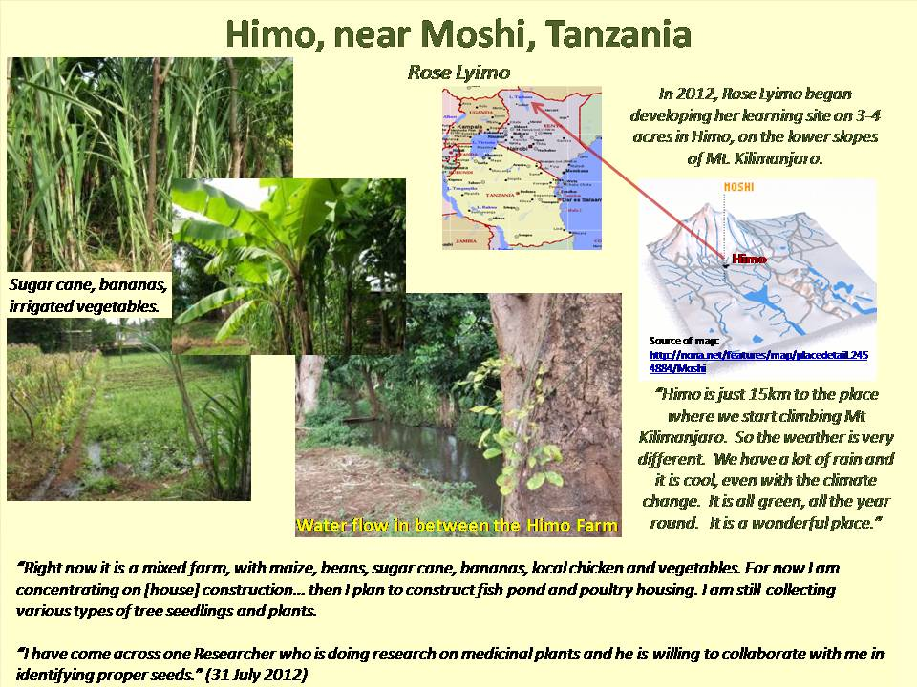  LESSONS LEARNED: “I think we have succeeded to be able continue learning, but at the same time to let other people know what we are doing. … They appreciate what we are doing. That is why some of them have expressed interest to be part of the project. That tells us that we are on the right track.” | In 2009, Rose Lyimo proposed creating a Barbet site in Ikwiriri, Rufiji, Tanzania. She began negotiating for a 99-year lease on village land near a long lake. She wanted to create an eco-tourism site and learn how to be an aggregator, pooling carbon sequestration services provided by local forests. These two activities would provide new local incomes while protecting the forests and their carbon absorption.  Although local leaders supported her, by 2012, she had not been able to secure either government permission or the finance required to build a site in Rufiji.  In 2012, Rose abandoned the Ikwiriri project and started creating her Barbet site on 3-4 acres of land at the edge of Himo, a town near Moshi. She began planting fruit trees, spices and medicinal plants. “I am going to concentrate on fruits and medicinal plants. ... I am going to concentrate on those things that either detoxify your body or treat you.”  “There is a problem with pharmaceuticals, especially malaria which is resistant to medicine. So many people are trying herbs. They are relying on those that have been identified locally, produced locally, distributed locally. And they seem to be really treating people.”

Woodland Valley Farm

Chris Jones, Ladock, Cornwall, England

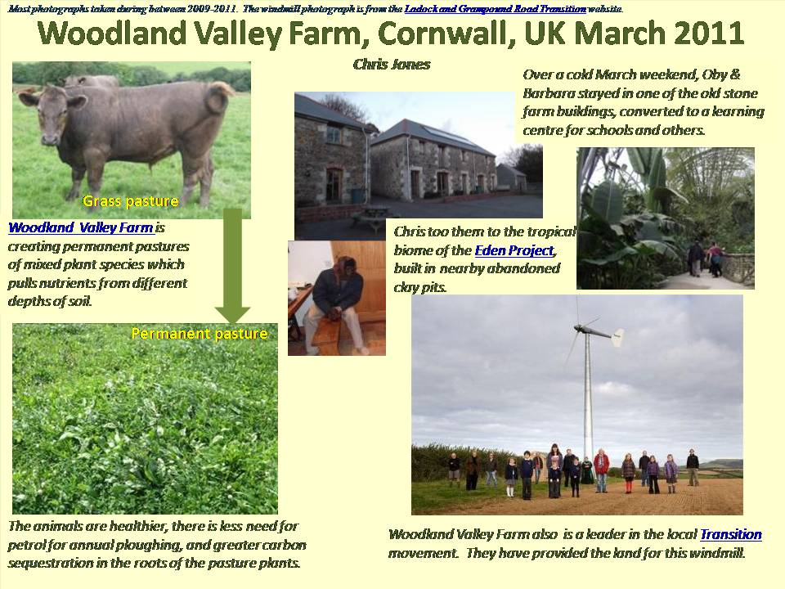  LESSONS LEARNED: “The benefits for me are: broadening the way we think about our land and its management; belonging to a group that freely shares information and seeing ourselves as connected with other people who are thinking along broadly similar lines.” | There are three strong elements to the work at Woodland Valley Farm. First, is the ongoing effort to maintain and improve their organic farming of beef and pork. The conversion of at least two pastures from grass to permanent pasture of mixed species is an example of that.  Second, after taking a financial beating during the BSE and foot and mouth epidemics, which did not affect the herd, but did affect the price paid for animals, Chris and Janet Jones began diversifying their sources of income. An important decision was made to convert the old stone farm buildings to a study centre and dormitory. School groups and others use the farm as an outdoor classroom with a large room for dining, seminars and other indoor work.  Third, Chris Jones has been active in the local Transition movement. The group is working to respond to the dual challenge of peak oil and climate change. In 2010, they won the Sustainable Village of the Year award in Cornwall, which led to the making of this video.  Woodland Valley Farm is an important partner in the Barbets Duet. It is another rural area facing similar challenges to those faced by the Learning sites in East Africa.
Hannacroix Creek
Barbara Heinzen, New Baltimore, NY, USA

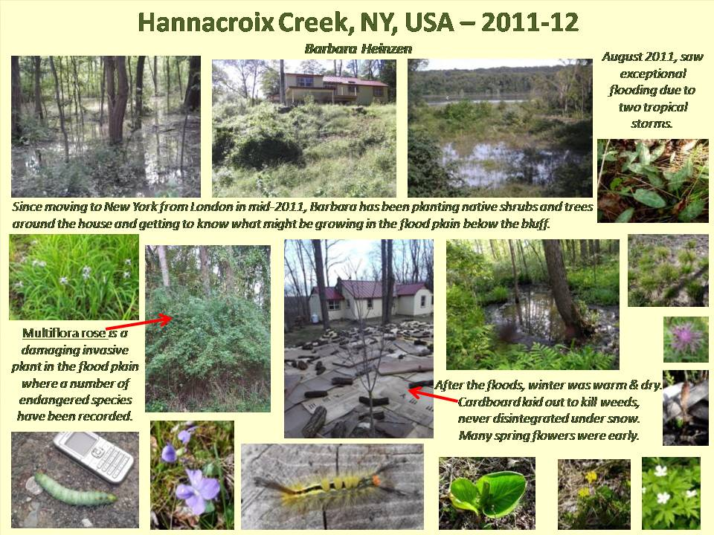  LESSONS LEARNED: “I remain like Magode persuaded that we are on the right track. [But] the reality of making progress is certainly tougher than I, for one, ever imagined.” | In mid-2011, after living in London, UK for 30 years, Barbara Heinzen, moved to her own learning site – about 19 acres of wetlands at the junction of the Hudson River and Hannacroix Creek.  She first became interested in the Barbets Duet because she saw a need to create a market that would protect biodiversity, along with other ecosystem services. This site will be a good place to test that idea, but initial work has focused on making the house habitable and planting more native trees and shrubs in the immediate garden.  Like other learning sites, this one has also experienced peculiar weather – with heavy tropical storms in August 2011, followed by an exceptionally warm and dry winter  The biggest challenge in managing the site is the presence of invasive species. A government forestry advisor said he had never seen a site with so many protected species and so many invasives. Clearing them out will be an expensive process lasting 3-4 years. There are some government programmes to help cover the cost, but finding the investment money needed will be hard. And, in the absence of a biodiversity market, it will be investment with no clear financial return.
Intern’s Debriefing
Thomas Dauncey, Imperial College, London, UK

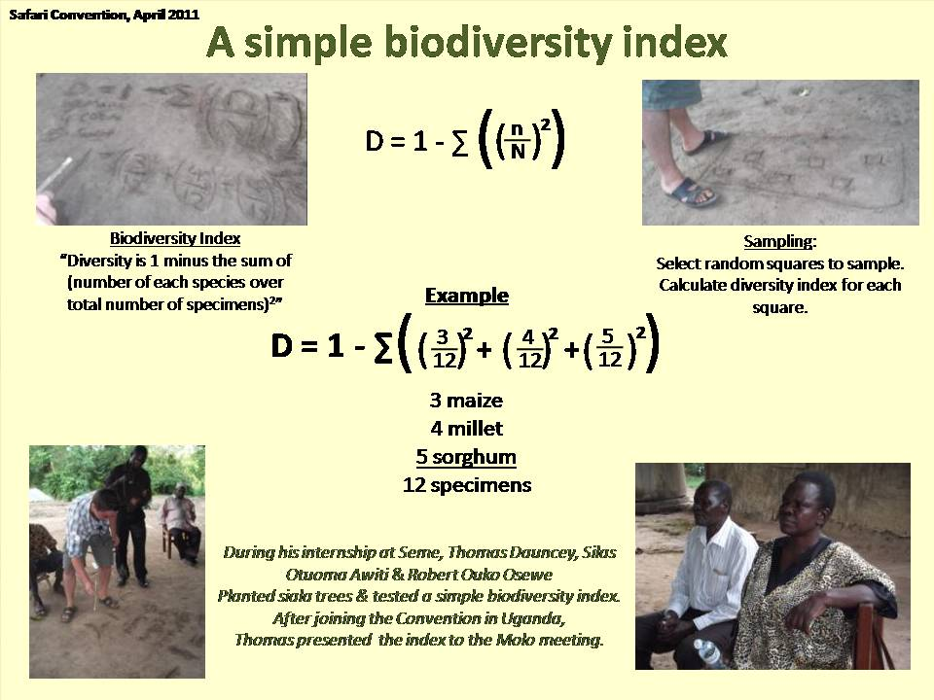  LESSONS LEARNED: “The big thing is how different the world is. It is a cliché, but until you live there, you don’t comprehend the difference.” | Thomas Dauncey, now at Imperial College in London, decided to spend part of his 2011 gap year as a Barbets Duet intern. Oby and Hilda had already hosted three young Americans at Seme, and agreed for Thomas to work there. After a delayed start because of the lack of rain, he worked with Robert Ouko Osewe and Silas Otuoma Awiti (now at Nairobi University) to plant the Siala trees. “It was fantastic working with Silas and Robert. We are about the same age and shared many interests.”  The three young men also tested a biodiversity index, using it to create a baseline against which improvements in the site can be measured. When Thomas joined the Safari Convention in Molo, Uganda, he presented the biodiversity index to the others. A reliable, easy to use index could help sites measure their progress and serve as a tradable ecosystem index.  When asked what he learned from his experience, Thomas said, “It was fun to learn how little we actually need. I was so pleased when the electricity came on [in Seme], then once it was there I wondered whether we really needed it.”  Would he recommend doing this to others? “Yes, but not to anyone. It needs to be the right interest and the right personality.”
Environmmental Markets
Where are they?

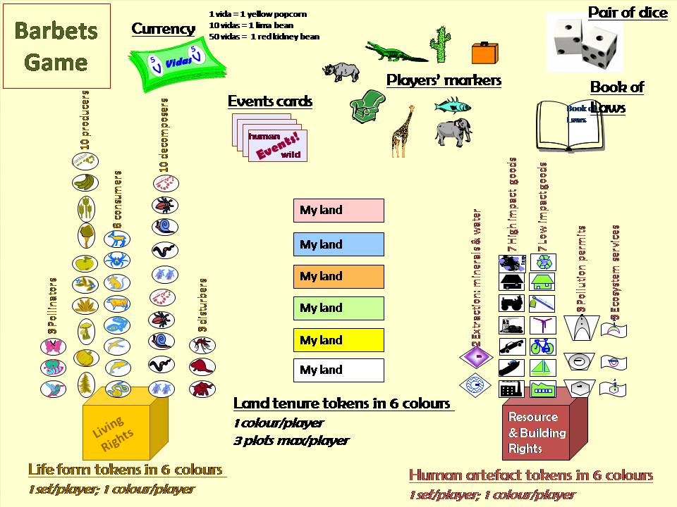 | The original thinking behind the Barbets Duet postulated that Barbet Learning sites could improve their income by participating in environmental markets. However, this is still a very elusive goal.  There are examples in the literature of communities earning money from tourism (an aesthetic market), but none of the Barbet sites are near major sanctuaries. Carbon markets should provide some income, but they are dominated by large formal players and tend to exclude our small acreage. Biodiversity markets could be beneficial, but are still closer to theory than practice and tend to be based on buying large tracts of land rather than paying small holders for good management.  In the absence of functioning environmental markets, Barbet partners have been developing the Barbet Game to test different trading practices. The best players have been children who quickly invent new rules and relationships to promote the multiplication of all forms of life. Eventually, the Game will be played by larger groups using competing sets of rules to see which produce the greatest biodiversity and greatest social equity.

Closing Observations

Four years have now passed since people first agreed to create Barbet Learning Sites. What have we been learning?

First, the importance and validity of the initial thinking has been largely reinforced. The need to integrate environmental thinking and goals in all land use and economic activity is still at the heart of each learning site. The use of local knowledge has also been increasing, year by year, often in surprising ways. The partners’ ability to learn from different cultures is proving to be a source of considerable achievement and respect. Finally, the learning sites have demonstrated the value of persistent experimentation and of sharing the results of what has been tried. By combining book learning and experiential learning, an invaluable equity of knowledge has been achieved, increasing the practical and intellectual resources available to all.

The challenges faced by each site, however, are considerable. The limits of capital and labour are often felt, slowing the rate at which good ideas can be tested in practice. There has also been a recurrent need to negotiate with neighbours, family and others on the wisest use of the land and its resources. It has taken time for others to experience the utility of what is being tried and begin to adopt the most successful practices. Partners have also been repeatedly thrown by unexpected outcomes, experiments that did not work as planned. Rather than quitting, they have learned from these experiences and are increasingly able to invest their time and money in better-targeted efforts. All this has taken time, demonstrating yet again how quickly ideas can be expressed compared to the years needed to realize them. Finally, nearly every site has experienced some form of weird weather in the past four years – floods, failed rains, exceptionally high temperatures or a change in the seasonal patterns. Climate change is a reality that has repeatedly confused everything being tried.

One of the central goals of the Barbet Partners is a desire to experiment with participating in – or even creating – environmental markets that would reward those who supported the natural world and its ecosystem services, such as water quality, biodiversity and carbon sequestration. So far, this goal has remained elusive. There is still a huge gap between what is being discussed theoretically or planned at high government and intergovernmental bodies and what land managers themselves are experiencing and need, especially among small holders.

This is unfortunate. Every Barbet Learning Site is self-financing and needs to be economically viable, to create real livelihoods for people on the ground. In the first instance, this is being done through the sale of new products in existing markets, but this does not necessarily pay for the increased investment in environmental restoration and care. As the partners gain confidence and experience, they will be better able to tackle this larger challenge and will begin to attract support from those approaching this challenge from a more theoretical perspective.

In the meantime, the commitment of all remains astonishingly high. No one who began in 2008 has dropped out. Instead, they have expanded their ideas, investments and activities, maintaining a style of open experiment and shared learning. It is this, as much as the original thinking of the Partners, that has encouraged others to think, “Perhaps I should start a learning site of my own”.

